1. 
2. Rest:  
   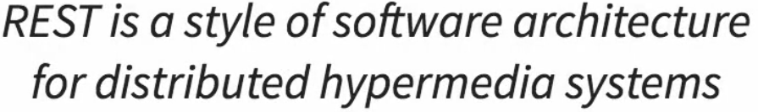
   1. Rest is a style of how you design your resources and
   2. How you expose them using HTTP.
   3. REST aims to make best use of HTTP. So, we want to make the best use of whatever HTTP provides (HTTP Methods & Status Code).  
      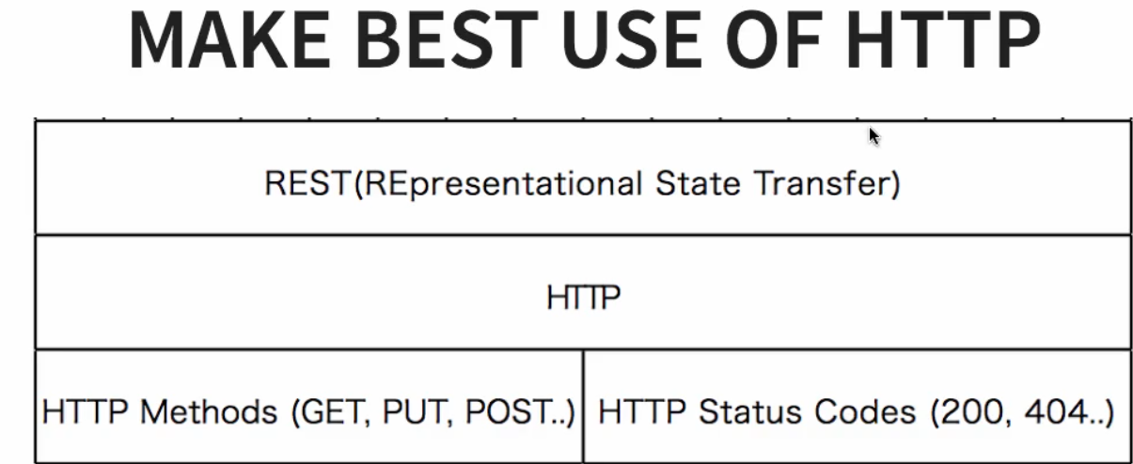
   4. 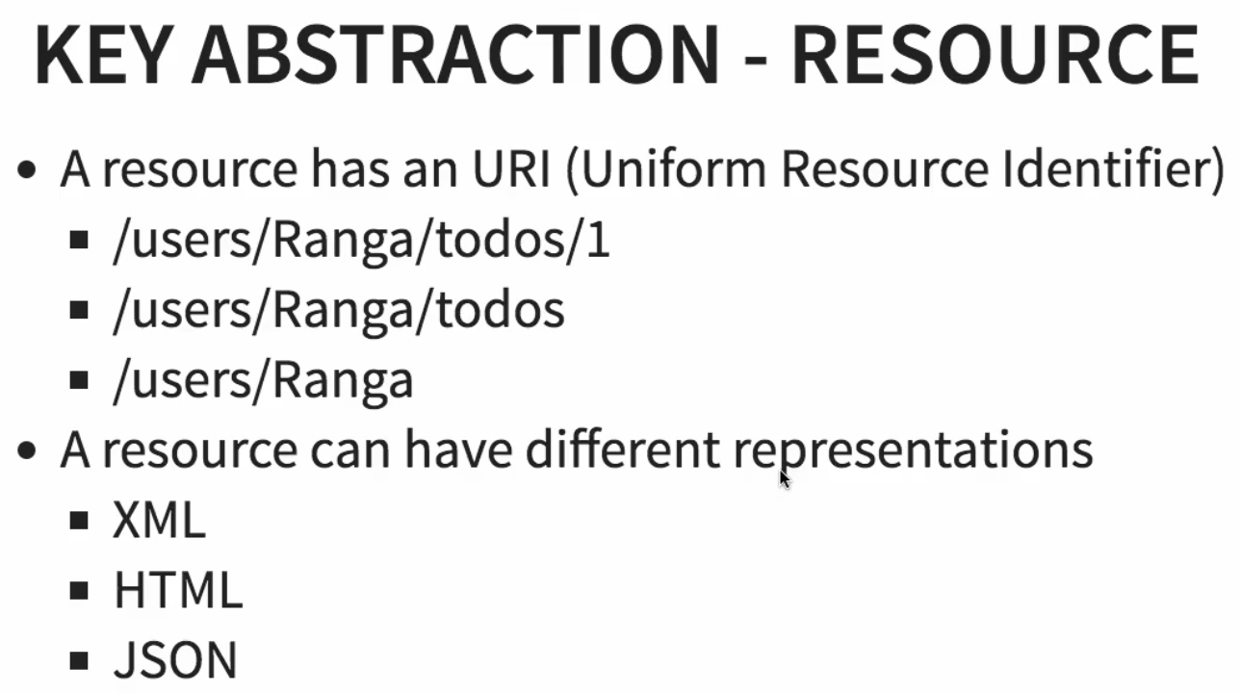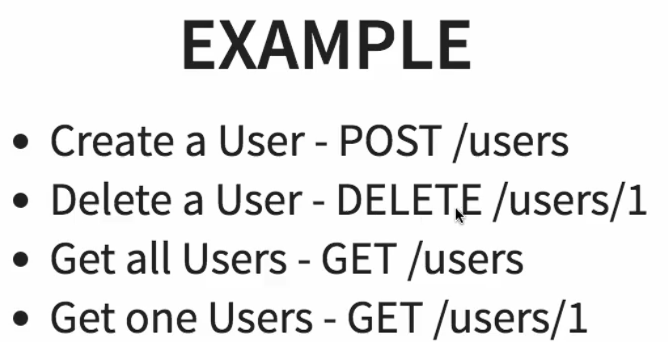
3. 